**Examination of Digital Mammogram using Otsu’s Function and Watershed Segmentation**

S.P. Sachin raj, N. Sri Madhava Raja, M.R. Madhumitha, V. Rajinikanth

Department of Electronics and Instrumentation Engineering,

St.Joseph’s College of Engineering,Chennai

A novel hybrid approach based on the combination Otsu’s multi-thresholding and Water Shed Segmentation (WSS) to mine the suspicious sections from the DM. Initially, the multi-level thresholding using the Bat Algorithm

(BA) driven Otsu with a bi-, tri- and four-level thresholding is implemented to pre-process the DM. Afterward, a marker controlled WSS is implemented to mine the infected division of DM. The mined section is then evaluated using the Haralick texture feature in order to know the severity of the disease by examining its texture feature. In this paper, DM dataset with dense, medium, low and normal breast regions are analyzed independently with the proposed approach. The experimental result of this paper confirms that, proposed method is very proficient in extracting the breast malignancy from the considered DM database.

Hence, in this paper a recent heuristic procedure called Bat Algorithm (BA)  is considered to examine the DM image database. The implemented technique

is the combination of a multi-level thresholding based on the BA and Otsu’s thresholding and segmentation based on the Watershed. The advantage of the thresholding and segmentation procedures are confirmed with the image quality measures and the GLCM values respectively.

**Methodology**

Initially, the 2D DM is extracted from the mini-MIAS and it is then thresholded

with CBA+Otsu. The outcome of thresholding is then processed with the watershed algorithm and the region of interest (ROI) is extracted. Finally, the GLCM features for the ROI are extracted. Based on the GLCM values, it can be classified into benign and malignant.

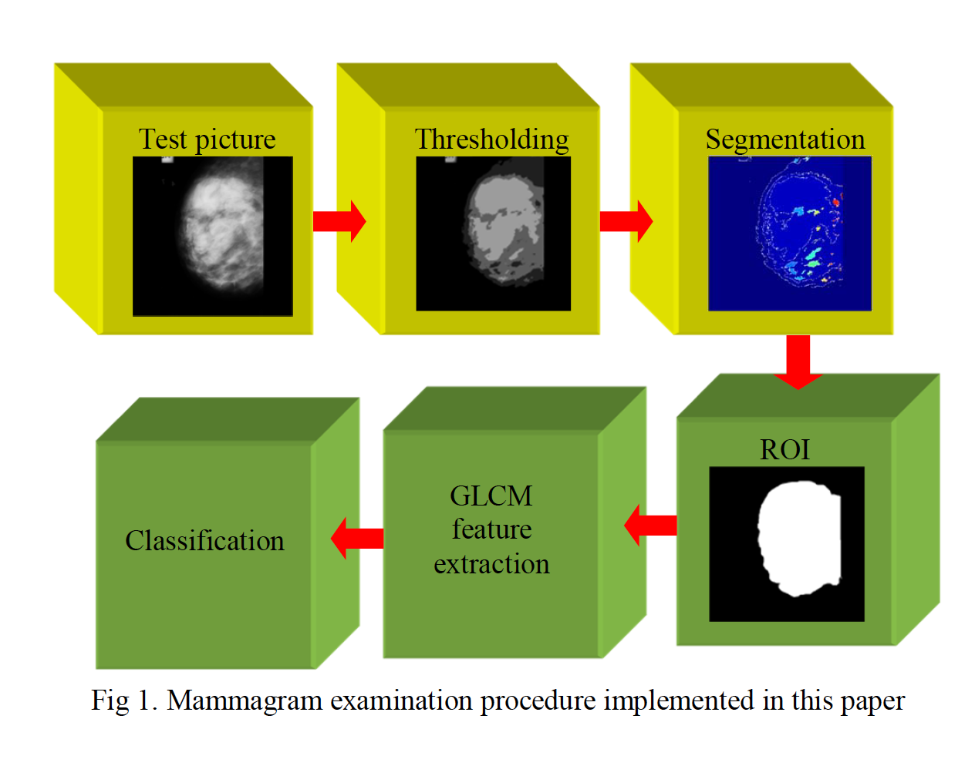

Dataset:

Digital mammogram (DM) is normally recorded using Xray on a chosen breast section. 2D DM pictures considered in this paper are obtained from the benchmark mini-MIAS database more than 50 in both malignant and benign subjects are considered . This dataset has a gray scaled 2D DM with major category as benign and malignant and sub classification as fatty, fatty-glandular and dense-glandular. This work considers the mini-MIAS and segregates the DM images into four classes, like normal, low, medium and dense based on the size of the irregularity.

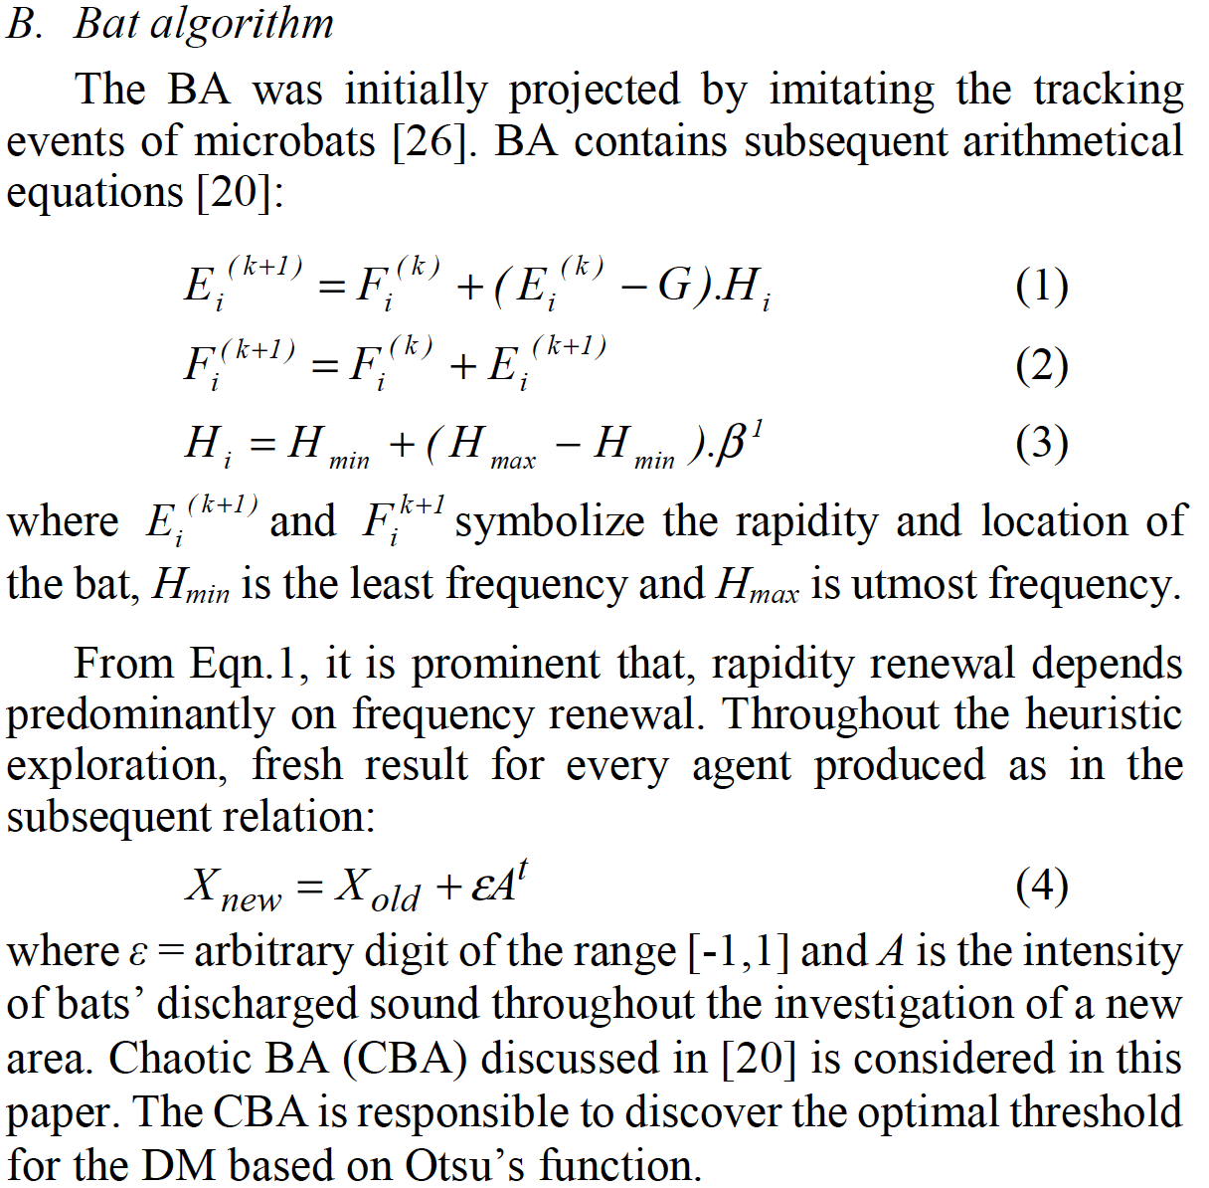

Otsu Thresholding

Let us consider that there are thresholds , such as t1,

t2, and tm, which partition the input picture into separate

sections, such as C0 (gray levels of range 0 to t1-1), C1 (gray

levels of range t1 to t2-1) and, Cm (gray levels of range tm-1 to L-

1). Where L = 256.

Objective value for this multi- thresholding can be expressed as;

Jmax = σ0 + σ1+… + σm (5)

More aspect regarding the Otsu is existing in the literature.

Eqn.4 is known as the Otsu’s between class variance function

which supports the exploration process of Chaotic BA search.

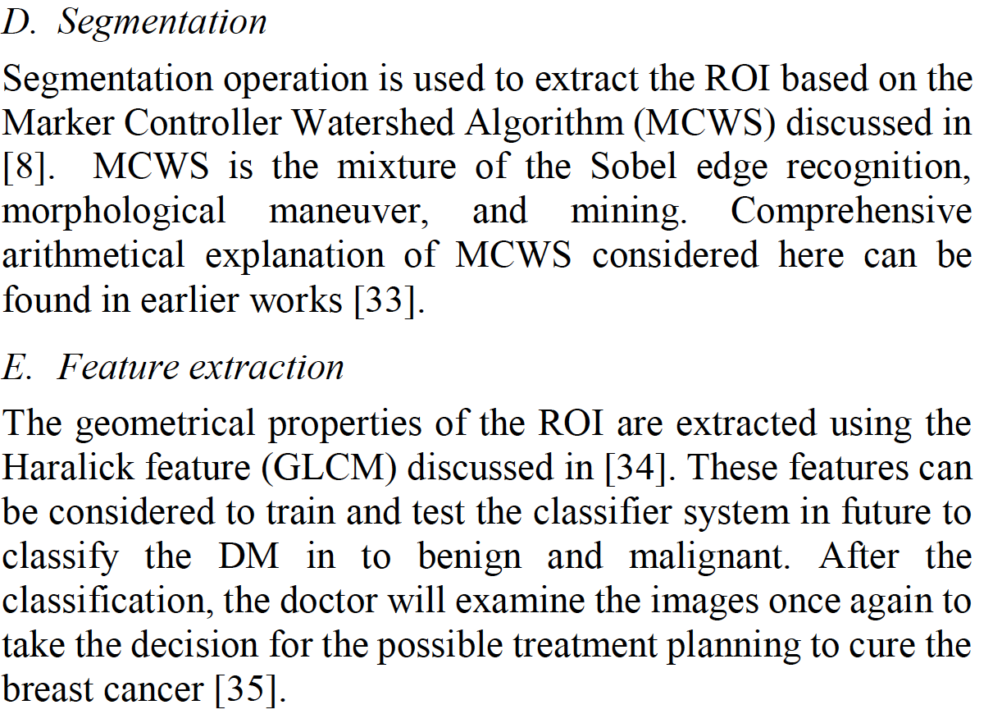

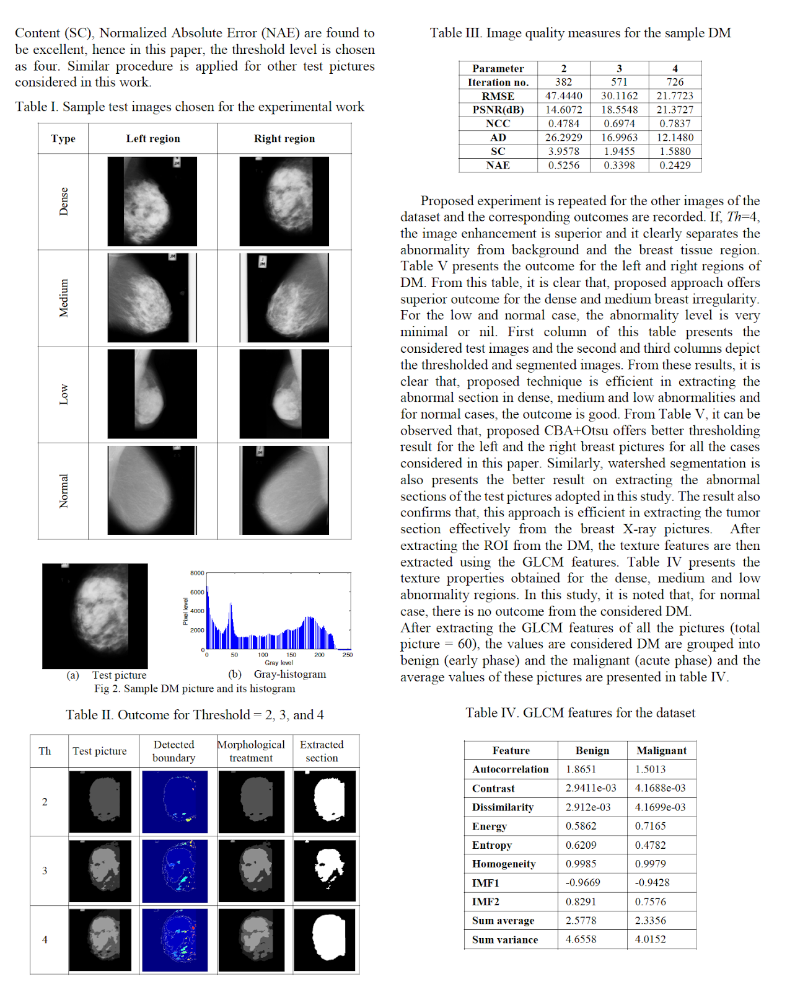

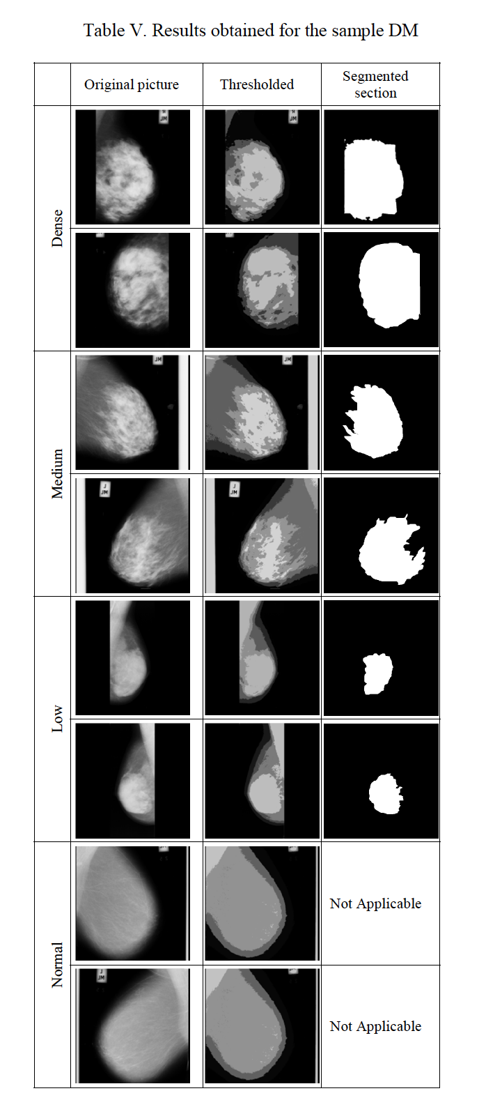

**Conclusion**

In this paper, a technique is proposed based on the combination of **multi-thresholding and Watershed Segmentation (WS) to examine the Digital Mammogram (DM) dataset of mini-MIAS. Initially, CBA+Otsu based thresholding is implemented to enhance the abnormal section from the DM. later; the improved section is extracted using the WS.** Later, the texture properties of the extracted section is computed based on the **GLCM**. In this work pictures, like dense, medium, low and normal images are examined using the proposed approach and is classified into benign and malignant based on its GLCM values. The results of this study confirm that, proposed approach is efficient in mining the abnormal section from the DM. In future, the proposed approach is to be compared against the related approaches already proposed by the researchers and a classifier system is to be implemented to classify the DM dataset into various disease classes. Further, validations with their corresponding ground truths can also be compared to estimate the efficacy of the segmentation.